SIMATS ENGINEERING
ASSESSMENT TOOL 1

COURSE NAME: Ethical Hacking COURSE CODE: ITA1435 COURSE OUTCOME COVERED
CO2: Execute foot printing in social engineering such as DNS analysis, competitive intelligence gathering, and attack simulations to collect relevant information for identifying potential security risks.

Assessment Tool Weightage: 30%

Duration: 90 min Total Marks: 50

Report Analysis

Questions

- A security analyst performed a network scan on the target 192.168.1.10 using the Nmap tool. The report identified several open ports, including HTTP (80), SSH (22), and MySQL (3306), along with the operating system and service versions. Analyze the report and explain the security risks associated with the identified services. Discuss how an attacker could exploit these services and recommend suitable security measures to protect the target system. (20 Marks)

- A phishing awareness campaign was conducted for employees of ABC Technologies Pvt. Ltd. using the GoPhish tool. The report indicates that 40% of employees clicked the phishing link, 20% entered their login credentials, and several users downloaded a malicious attachment. Analyze the report and identify the security weaknesses demonstrated by the employees. Recommend suitable user awareness programs, email security controls, and organizational policies to reduce the risk of successful social engineering attacks.(20 Mark).

- A DNS assessment report generated using the Dig tool shows that the organization's DNS server permits a successful DNS Zone Transfer (AXFR), exposing internal hostnames, mail servers, and DNS records. Analyze the report and explain the security implications of the exposed information. Discuss how attackers could exploit these findings and recommend best practices to secure the DNS infrastructure..(10 Marks)

Code of Conduct:
I Pulipakukla Akhil Kumar (192373024) (Name / Reg No) certify that this submission is my original work and that I have adhered to the guidelines specified for this assessment.
I understand that any violation of academic integrity rules will result in disciplinary action.
Signature of the student: P.Akhil

RUBRICS FOR CALCULATION

Report Analysis
Criteria | Weightage (%) | Level 4 (Exemplary) | Level 3 (Proficient) | Level 2 (Developing) | Level 1 (Beginning)
Report Analysis and Interpretation | 25% | Accurately interprets the security report, identifies all key findings, and explains their significance with excellent technical understanding. | Correctly interprets most findings with minor omissions or inaccuracies. | Identifies only some findings and provides limited  interpretation. | Unable to interpret the report or identify key findings.
Identificati on of Security Risks and Vulnerabili tie s | 25% | Correctly identifies all security risks, vulnerabilities, and possible attack vectors with clear technical justification. | Identifies most risks and vulnerabilities with minor errors. | Identifies only a few risks with limited technical explanation. | Fails to identify major risks or vulnerabiliti es.
Applicati on of Cybersecu  rit y Concepts  and Counterm eas ures | 30% | Applies appropriate ethical hacking concepts and recommends comprehensive, practical, and  technically sound countermeasures. | Recommends suitable countermeasur e s with minor technical gaps. | Provides limited or partially appropriate recommend atio ns. | Recommen dati ons are inappropria te, incomplete  , or missing.
Technical Communic ati on and Document ati on | 20% | Response is well organized, technically accurate, clearly presented, and uses appropriate cybersecurity terminology throughout. | Response is organized and understandable with minor documentation or presentation issues. | Response lacks clarity,  organization, or contains several technical inaccuracies. | Response is poorly organized, incomplete, and difficult to understand.

Question 1: Nmap Scan of 192.168.1.10

Report Analysis and Interpretation
The analyst ran an Nmap service and OS detection scan (for example nmap -sV -O -p-192.168.1.10). The scan shows that the host exposes three network services directly to the scanner. Each open port is an entry point and reveals software names and versions, which an attacker uses to look up known vulnerabilities.

Port | Service | Sample version (illustrative) | Interpretation
22/tcp | SSH | OpenSSH 7.2p2 (Ubuntu) | Remote administration is reachable. Old version and password logins make it a brute-force target.
80/tcp | HTTP | Apache httpd 2.4.18 | Unencrypted web service. Outdated server and web apps may contain exploitable flaws.
3306/tcp | MySQL | MySQL 5.7.x | Database port exposed to the network. It should normally be reachable only from the application server.
OS | Linux | Linux 3.x – 4.x (OS fingerprint) | OS and version details help the attacker choose matching exploits (information disclosure).

Key finding: the attack surface is larger than necessary. Three services plus version banners give an attacker everything needed to start targeted exploitation without any prior access.

Security Risks of the Identified Services
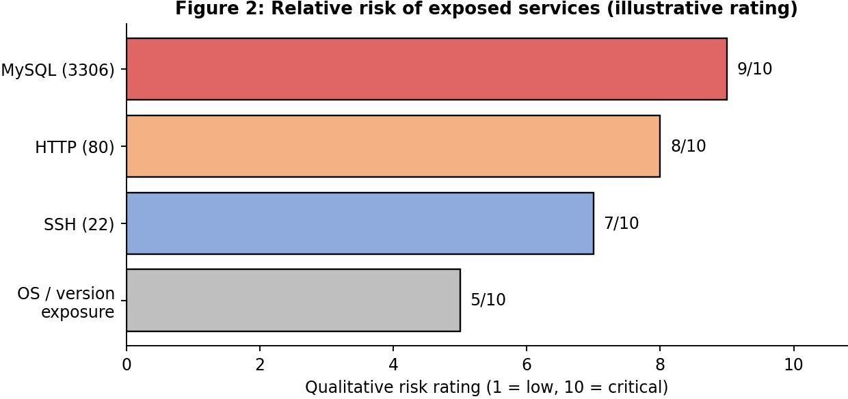

Service | Security risks / vulnerabilities | Possible attack vectors
SSH (22) | Weak or reused passwords No rate limiting on logins  Outdated OpenSSH (e.g. CVE-2016-6210 user enumeration in 7.2p2) Root login allowed | Brute-force and dictionary attacks (Hydra, Medusa)  Credential stuffing Username enumeration Stolen private keys
HTTP (80) | No encryption (credentials sent in clear text)  Outdated Apache and CMS/plugins Misconfiguration, directory listing Injection flaws (SQLi, XSS, file upload) | Web vulnerability scanning (Nikto) SQL injection (sqlmap)  Man-in-the-middle sniffing  Web shell upload for remote code execution
MySQL (3306) | Database reachable from outside Weak or default root password Remote root login enabled  Unpatched version, sensitive data at risk | Password brute force  Direct login with stolen credentials Exploiting known CVEs  Dumping tables and data exfiltration
OS / banners | Version information disclosure Missing patches | Exploit matching via Searchsploit / Metasploit Privilege escalation after foothold

How an Attacker Could Exploit These Services (Step by Step)
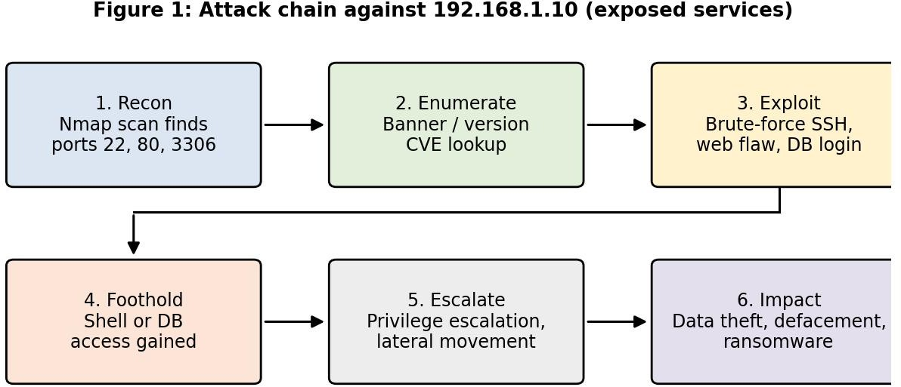

Step 1: Reconnaissance: run Nmap to list open ports 22, 80 and 3306 with versions and OS.
Step 2: Enumeration: read banners, search CVE databases (NVD, Exploit-DB) for each version, and run Nikto or directory scans on port 80.
Step 3: Initial access: brute-force SSH or MySQL passwords, or exploit a web flaw such as SQL injection or file upload to get a web shell.
Step 4: Foothold and persistence: obtain a shell, create hidden users or SSH keys, and install a backdoor.
Step 5: Privilege escalation and lateral movement: use kernel or sudo misconfigurations to become root, then pivot to other hosts in 192.168.1.0/24.
Step 6: Impact: steal or modify database records, deface the website, deploy ransomware, or use the server in a botnet.

Recommended Security Measures

Area | Countermeasures
SSH | Disable password login and use key-based authentication Set PermitRootLogin no and MaxAuthTries 3  Install fail2ban, change exposure with firewall allow-list or VPN/bastion host Upgrade OpenSSH and enable MFA
HTTP | Move to HTTPS (TLS 1.2+), redirect port 80 to 443 and enable HSTS Patch Apache and applications, hide version (ServerTokens Prod)  Deploy a Web Application Firewall (ModSecurity), validate input and use prepared statements Disable directory listing and unused modules
MySQL | Set bind-address = 127.0.0.1 or restrict to the app server IP Block 3306 at the firewall  Strong passwords, remove anonymous and remote root accounts, apply least-privilege users Enable TLS for connections and encrypted backups
System / network | Run mysql_secure_installation, apply regular patch management Default-deny firewall (UFW/iptables), close all unused ports  IDS/IPS (Snort/Suricata), centralised logging and alerts Periodic vulnerability scans and penetration tests

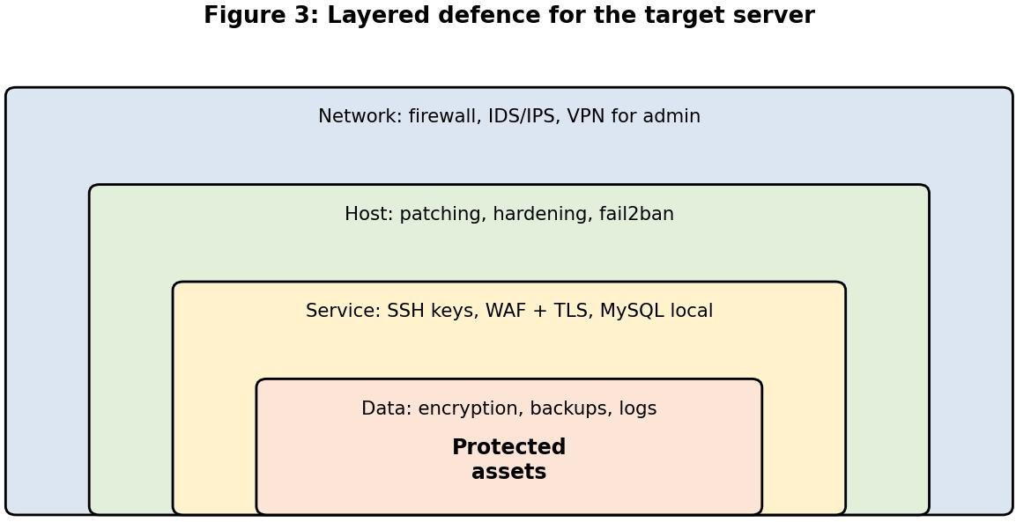

Conclusion: the open SSH, HTTP and MySQL services with visible versions create a clear attack path. Closing unnecessary ports, patching, strong authentication, encryption and layered monitoring reduce the risk to an acceptable level.

Question 2: GoPhish Phishing Campaign – ABC Technologies Pvt. Ltd.

Report Analysis and Interpretation
GoPhish was used to send simulated phishing emails with a link to a fake login page and a malicious attachment. The campaign measures how many users trust the message (clicks), how many give away secrets (credential submission) and how many run untrusted files (attachment downloads).
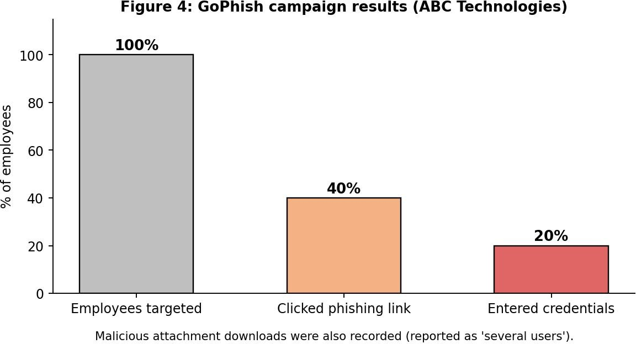

Metric | Result | Interpretation
Clicked phishing link | 40% | Two in five employees trusted an unverified link. This is a high click rate, so the first line of defence (human awareness) is weak.
Entered credentials | 20% | Half of those who clicked also submitted a username and password. Real accounts would be compromised.
Downloaded attachment | Several users | Users opened or saved untrusted files. A real payload could install malware or ransomware.

Security Weaknesses Demonstrated by Employees
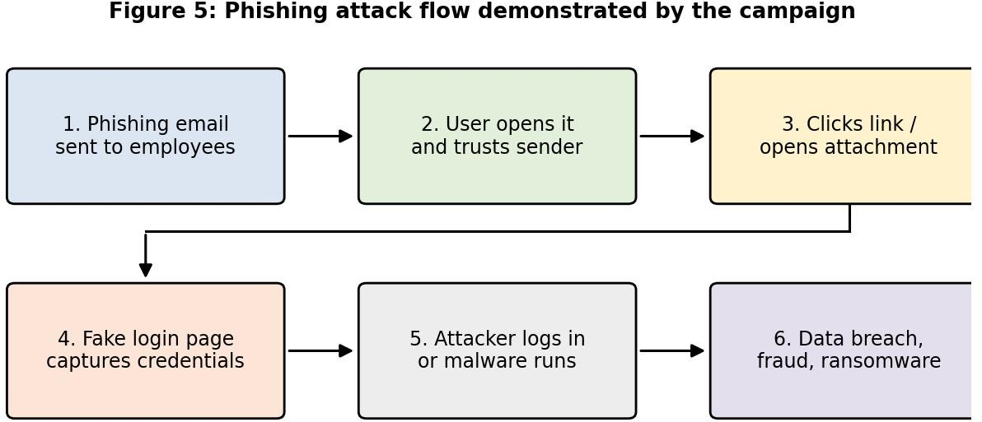

    - Lack of awareness: employees cannot recognise phishing indicators (urgent tone, spoofed sender, mismatched URL, generic greeting).
    - Poor link and URL hygiene: links were clicked without hovering to check the real destination.
    - Credential handling: passwords were typed into a fake page, showing no habit of verifying HTTPS, domain and context.
    - Unsafe attachment behaviour: files were downloaded and opened from unknown or unexpected senders.
    - Weak reporting culture: no sign that suspicious emails were reported to IT security.
    - Over-trust and pressure: social-engineering triggers such as authority, urgency and curiosity worked on a large share of staff.
    - Possible technical gaps: the emails reached inboxes, which suggests weak filtering, and stolen passwords would be enough because MFA may be missing.

Recommendations

User Awareness Programs
  - Mandatory induction and annual security-awareness training with real phishing examples.
  - Role-based training for high-risk groups (HR, finance, executives, IT help desk).
  - Regular simulated phishing campaigns with immediate "teachable moment" pages for users who fail.
  - Short micro-learning, posters and newsletters; teach the checklist: Stop, Look (sender, URL), Think, Report.
  - A one-click "Report Phishing" button and recognition for employees who report.
  - Track metrics (click rate, credential rate, report rate) and aim for steady reduction over time.

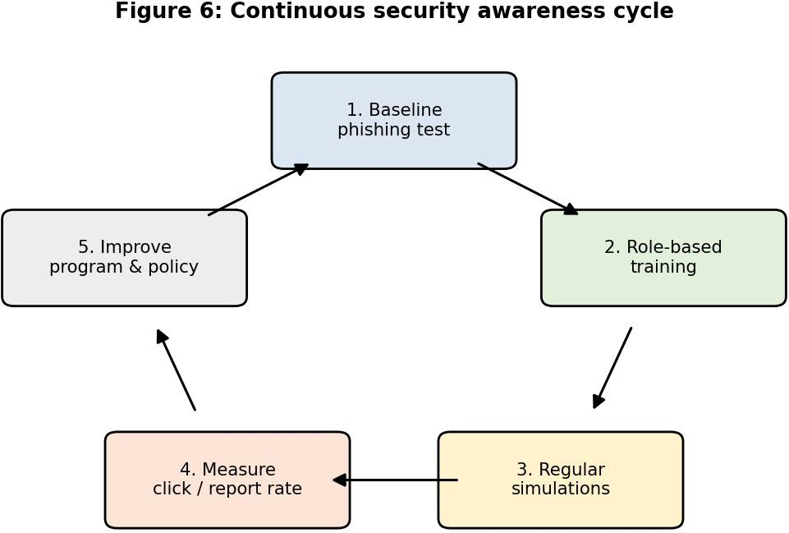

Email Security Controls

Control | Purpose
SPF, DKIM, DMARC | Authenticate senders and block spoofing of the company domain (move DMARC policy to quarantine/reject).
Secure email gateway / spam filter | Detect phishing keywords, malicious domains and bulk campaigns.
Attachment sandboxing and file-type blocking | Detonate attachments in isolation, block executables, scripts and macro-enabled Office files.
URL rewriting and web filtering | Check links at click time and block newly registered or malicious domains.
External sender banner | Warn users when email comes from outside the organisation.
Multi-factor authentication (MFA) | Stolen passwords alone cannot be used to log in.
Endpoint protection (EDR) and patching | Stop malware that runs after a user error.

Organizational Policies
  - Acceptable use and email policy: rules for links, attachments and personal use of work email.
  - Password and MFA policy: unique strong passwords, password manager, mandatory MFA on email and VPN.
  - Incident reporting and response policy: report within a fixed time; compromised accounts reset immediately.
  - Least privilege and access control: limit damage if an account is stolen.

  - Verification procedure: call-back confirmation for payment, credential or data requests (prevents BEC fraud).
  - Software installation and removable media policy: only approved software; block unknown downloads.
  - Non-punitive, accountability-based culture: encourage reporting; repeat offenders receive extra training.
  - Regular audits: review of phishing metrics by management and the security team. Conclusion: the 40% click rate and 20% credential submission show that people are the main weakness. A combination of continuous training, strong email controls and clear policies makes
social-engineering attacks much less likely to succeed.

Question 3: DNS Zone Transfer (AXFR) Using Dig

Report Analysis and Interpretation
The Dig report shows that the DNS server answered an AXFR request from an unauthorised client and returned the complete zone file. AXFR is meant only for replication to trusted secondary servers. Allowing it to anyone is a misconfiguration.
$ dig axfr abctech.example @ns1.abctech.example
abctech.example.
3600 IN SOA ns1.abctech.example.
admin.abctech.example. ...
abctech.example. mail.abctech.example. vpn.abctech.example. dev.abctech.example. db01.abctech.example.
; (illustrative output)
3600 IN MX
3600 IN A
3600 IN A
3600 IN A
3600 IN A
10 mail.abctech.example.
203.0.113.25
203.0.113.40
10.10.5.21
10.10.7.15

Security Implications of the Exposed Information

Exposed data | Implication
Internal hostnames (dev, db01, test) | Reveal network layout and naming convention; show where sensitive systems are located.
Mail servers (MX records) | Allow targeted phishing, spoofing and mail-server attacks.
IP addresses (including private ranges) | Give attackers a ready target list and show internal addressing, which saves scanning time.
Other records (TXT, CNAME, SRV, NS) | Expose third-party services, SPF details and service endpoints for further mapping.
Forgotten or test hosts | Often unpatched and an easy way in (subdomain takeover, weak systems).

This is a reconnaissance leak: it does not break in by itself, but it gives the attacker a complete map of the organisation, which makes later attacks faster, quieter and more precise.

How Attackers Could Exploit the Findings
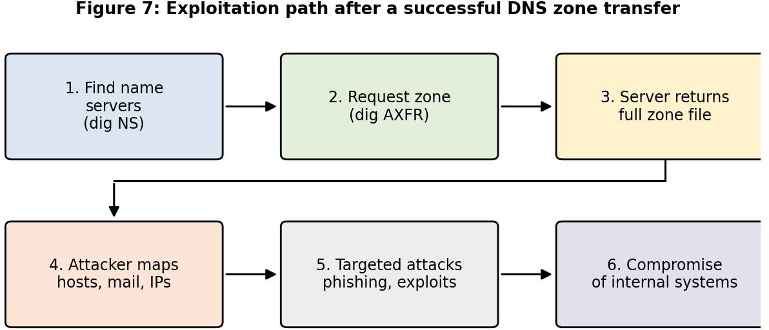

    - Use the host list to run Nmap against only the valuable systems (VPN, database, dev servers).
    - Attack weak development or test servers first, then pivot to internal networks.
    - Craft phishing emails that use real internal server names and mail hosts to look genuine.
    - Spoof or poison DNS for the discovered hosts, and look for dangling CNAMEs to take over subdomains.
    - Plan denial-of-service attacks on critical name servers or mail servers.

Best Practices to Secure DNS Infrastructure

Practice | Details
Restrict zone transfers | Allow AXFR only to listed secondary servers (allow-transfer), refuse all others.
Authenticate transfers | Use TSIG keys so only signed requests are accepted.
Split-horizon DNS | Keep internal records on an internal DNS server; publish only public records externally.
Firewall rules | Limit TCP/53 (zone transfers) to known secondary IPs; allow UDP/53 for normal queries.
DNSSEC | Sign zones to protect against spoofing and cache poisoning.
Housekeeping | Remove stale and test records; avoid descriptive internal names in public DNS.
Patching and hardening | Update BIND or other DNS software, disable recursion for outside clients, hide version.
Monitoring and testing | Log and alert on AXFR attempts; re-test with dig axfr regularly.

Example secure BIND configuration:
zone "abctech.example" { type master;
file "db.abctech.example";
allow-transfer { 203.0.113.53; key tsig-key; };
};

options { version "not disclosed"; allow-recursion { 10.0.0.0/8; }; };

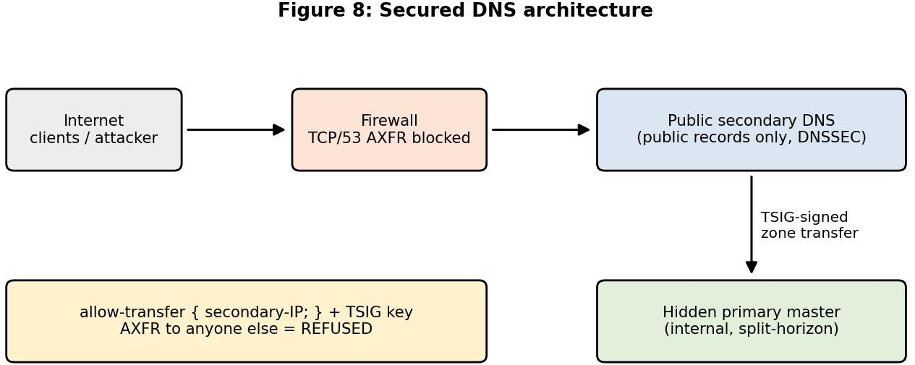

Conclusion: an open zone transfer hands attackers a map of the network. Restricting and signing transfers, separating internal and external DNS, and applying DNSSEC and monitoring close this exposure.

